Vending Machine Controller Project Documentation

- Introduction (Choi)
In this report, we present the thorough development steps and the results of our hardware design and prototyping project. This report serves to describe how we managed to develop a fully functional vending machine controller. The main development steps are
- Design in VHSIC Hardware Description Language (VHDL) on ModelSim.
- Functional verification of the design using test benches on ModelSim.
- FPGA design implementation on Vivado and hardware verification on the Nexys A7-100T development board.
- Custom PCB development using KiCad.
The vending machine controller aims to have the following available features.
- Selection of items (using switches)
- Display of the names and the prices of available items (using 8 digits of 7-segment display)
- Insertion of coins (using push buttons)
- Display of the inserted coin amounts (using 8 digits of 7-segment display)
- Display of the current state (using LEDs)
The design implemented a Moore Finite State Machine to handle the user interactions as well as internal processes. In other words, our team used Moore FSM in VHDL design that allows the output to be determined by the current state only, which will be explained further in the following sections.
- Team Members and Project Management (Choi)
2.1 Agile Development [2]
Our team followed the Agile Development approach as we learned it from Computer Science 2 class, previously at our university. Agile Development is an iterative and incremental development method that highlights the importance of flexibility, collaboration, and continuous improvement. Each team member had a leading role in each section of the project, but each member also gave feedback and helped one another in a weekly meeting (Scrum). In each meeting, we reviewed the current status of each task and shared feedback and challenges. In this way, we communicated very well within our group and took feedback from other members into the final result. Especially, agile method was especially well recognized for its effectiveness in hardware and software co-design projects and our vending machine controller project was thus successful.
2.2 Project Management using GitHub Repository and GitHub Project
To coordinate our project, we used GitHub Repository and GitHub project board. With these tools, we could organize different tasks successfully, specifically by following up each task progress and assigning responsibilities and deadlines for each task. With these tools, we could always be on the same page and be updated with the progress each member was making.

2.3 Roles and Responsibilities
Each member took a leading role in different parts of the project. Namely,
- Younsuk Choi: VHDL design of the FSM controller and peripheral integration, verification using test benches
- Yuming (Leano) Wang: VHDL code debugging and FPGA Implementation
- Muhammad Emaan Sajid: PCB Prototyping (Schematics, Layout, 3D view, BOM and Gerber Files)
As mentioned above, each member had a primary responsibility, while making sure that our collaboration was integral across all tasks. Each member not only led the development in each task but also helped other teammates in their respective tasks.
- Concept Description and Requirements (Choi)
3.1 Vending Machine Controller Concept
The main concept of our project is the design and implementation of a fully functional vending machine controller using VHDL on the FPGA platform (Nexys A7-100T), along with the custom PCB prototype. The vending machine controller manages user interaction through inputs (push buttons, switches, reset) and displays information via outputs (7-segment display and LEDs).
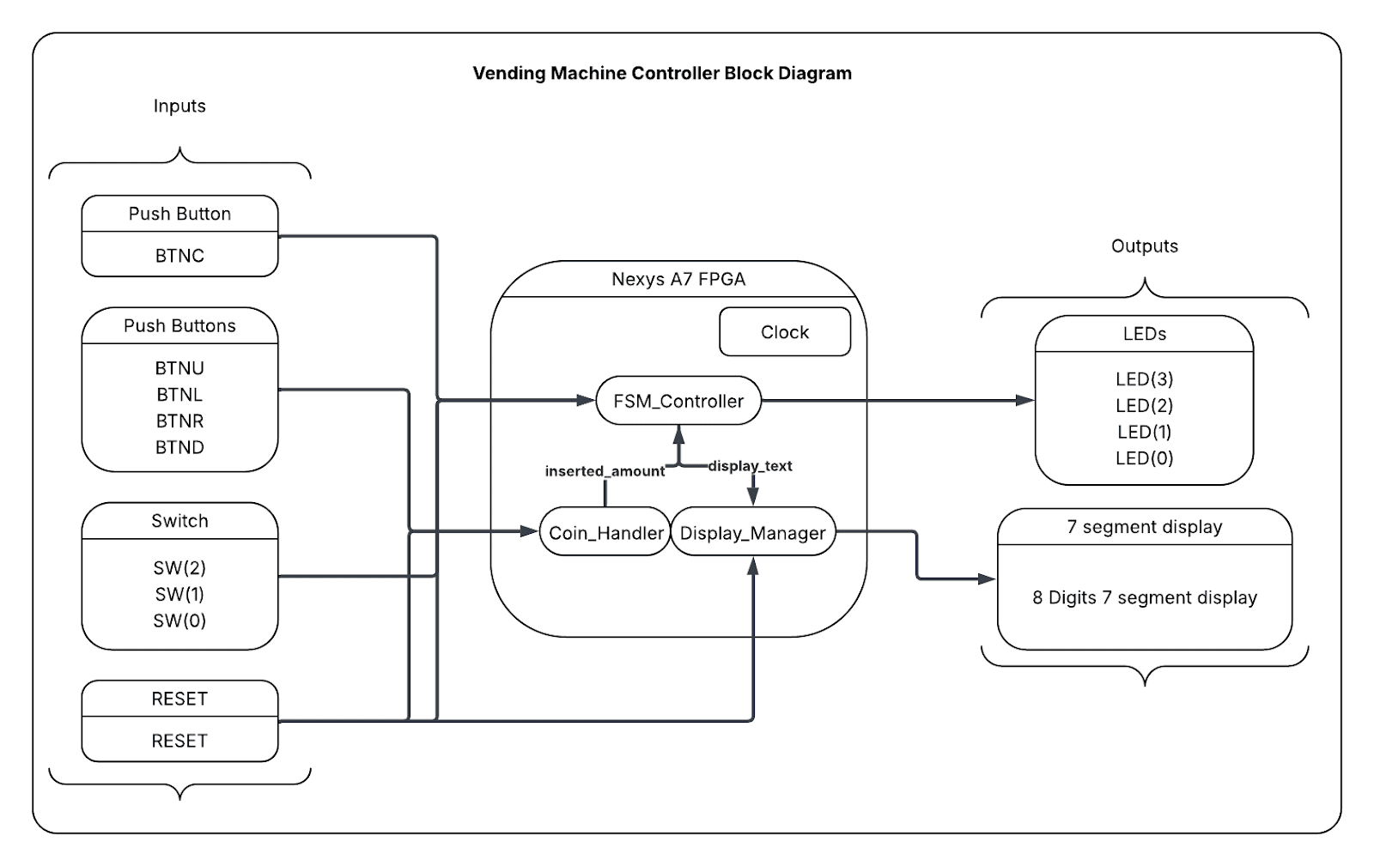
Figure 1. Block Diagram [1]
As Figure 1 shows, the block diagram of the vending machine controller explains different components used in the project. First, the push button BTNC, 3 switches, reset and inserted_amount from Coin_Handler are used for state transition logic in FSM_Controller unit. Secondly, 4 push buttons (BTNU, BTNL, BTNR, BTND) and reset are used for coin inserting logic in the Coin_Handler. Lastly, reset and display_text are used for display logic in Display_Manager unit.
Also, from the block diagram, one can see that four LEDs are used as outputs from the FSM_Controller unit. Furthermore, Display_Manager logic will use a 7-segment decoder for displaying the output.
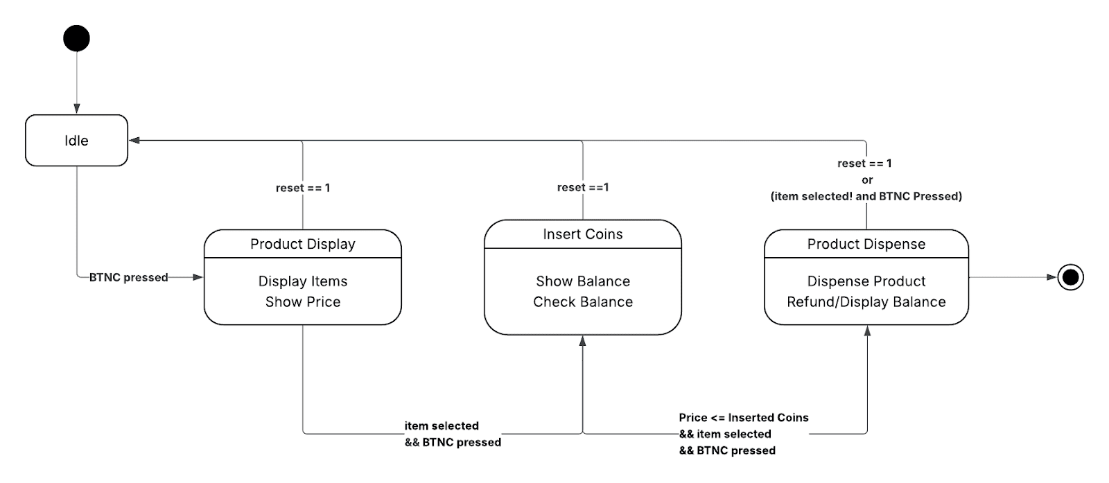
Figure 2. State Machine Diagram [1]
In Figure 2, the state machine diagram explains the core of the system in more detail. To be more specific, it is based on the Moore Finite State Machine that transitions through four different states: IDLE, DISPLAY, INSERT, DISPENSE. This FSM is responsible for controlling how the vending machine responds to the user actions:
- In IDLE, the system waits for BTNC_pressed to start interaction
- In DISPLAY, the user chooses an item using switches, and the system displays the selected product and price.
- In INSERT, the user inserts coins using push buttons, and system displays the required price and the inserted amount.
- In DISPENSE, if the inserted amount is greater than or equal to the required price, then it displays the balance and dispenses the product.
3.2 Requirements
Before we begin with the actual implementation, we formulated our requirements. These requirements evolved during the development period and the final requirements are as follows:
3.2.1 VHDL (Choi)
- Clearly defined Moore’s Finite State Machine with four states (IDLE, DISPLAY, INSERT, DISPENSE)
- Encoding of user interactions
  - Push buttons for coin insertion logic (BTNU = 10 cents, BTNL = 20 cents, BTNR = 50 cents, and BTND = 100 cents = 1 euro)
  - BTNC for state transition, item selection confirmation, inserted amount confirmation
  - Switches for item selection
- Display item names, their prices, and inserted amounts on an 8-digits of 7-segment display
- Calculation of change and display the change
- Simulation of picking the dispensed item from the vending machine by switching off the selected item switch
- Ensuring the state transitions and outputs are synchronized to the clock signal
- Verification using test benches with the maximum coverage as possible
3.2.2 FPGA (Leano)
For successful integration of the vending machine logic into FPGA hardware, the following requirements must be met:
- Synthesis of VHDL FSM Design onto the FPGA using Vivado, ensuring compatibility with the chosen board.
- Pin constraints (XDC file) must be properly assigned to bind logical inputs/outputs to physical hardware (buttons, switches, 7-segment display).
- Clock signal synchronization must be maintained across all modules. The system should operate in sync with the 100 MHz onboard clock to ensure consistent state transitions and output behavior.
- Proper instantiation of 7-segment decoder modules to display selected items, prices, inserted amounts, and change across 8 digits.
- Efficient resource mapping during synthesis and implementation to stay within the available LUTs, flip-flops, and I/O pins.
- Bitstream (.bit) generation and FPGA programming must be verified using Vivado hardware manager.
- Final design must be tested on hardware to validate that all inputs (buttons, switches) and outputs (display, item logic) work correctly in real-time.
This FPGA implementation ensures real-time interaction with the vending machine interface and bridges the logical VHDL design with the physical hardware environment.
3.2.3 PCB (Emaan)
For creating great PCB design, we have to fulfil these requirements. [6]
- Make sure the PCB outline is closed and clean so software and machines can understand where board starts and ends
- Every component must have the correct footprint (pad size, shape and spacing) matching the part you place on board
- Set the rules how wide your tracks should be, how far they can be and the size of vias (also known as holes).
- Place parts logically. For example, put power components together, keep signals flowing in a clear direction, and leave space for wiring.
- Plan how the electrical lines (tracks) will be drawn. Keep high-speed or sensitive signals short and away from noisy signals. Match track lengths if needed.
- Avoid short circuits by ensuring enough space between pads and tracks.
- Use Design Rule Checker (DRC) to find missing connections, fix and find any spacing.
- Use KiCad 3D view to check how board will look in real life.

- Explanation of Important Used Technologies
4.1 VHDL, ModelSim and Test Benches [3,4,5] (Choi)
VHDL stands for Very High-Speed Integrated Circuit Hardware Description Language. It means it is the hardware description language used to model and design electronic systems such as digital logic circuits. It allows description of the structure and behavior of hardware at various abstraction levels. In this project, VHDL was used to implement the core logic of the vending machine controller as Finite State Machine. This allowed us to have a precise control of the system’s behavior across different states. VHDL also supports simulation and verification by using tools such as ModelSim.
ModelSim supports different HDL such as VHDL, Verilog, etc. This tool was specifically useful for us because we could not only write the code but also simulate the behavior of the code and analyze the waveforms of test benches for verification purpose.
Test bench is what we write to verify the functionalities of the implemented hardware design. It is simulating the device under test with our predefined input sequences to be tested and allows us to check for the expected outcome. This is a very important step before deploying our design to the FPGA board because it ensures the design works as we intend it to work.
4.2 FPGA and Vivado (Leano)
FPGA stands for Field Programmable Gate Array. It is a type of integrated circuit that can be configured by the user after manufacturing. Unlike traditional microcontrollers or processors, FPGAs contain an array of logic blocks and reconfigurable interconnects, allowing custom digital circuits to be built within the chip.
FPGAs enable parallel data processing and are widely used in:
- Real-time systems
- Signal processing
- Communication systems
- Embedded hardware acceleration
Vivado is a development environment provided by Xilinx (now part of AMD) for designing and programming FPGAs. It allows users to:
- Design digital logic using VHDL, Verilog, or graphical block design
- Simulate and verify the behavior of circuits
- Synthesize the logic into actual hardware implementation
- Generate bitstreams for programming the FPGA
Vivado supports a range of Xilinx FPGA devices and includes tools like logic analyzers, IP integrators, and constraint editors.
4.3 PCB and KiCad (Emaan)
PCB (Printed Circuit Board) is a flat board that holds and connects electronic components using wires. PCB prototyping is a process of designing and creating a test version of PCB before full scale production. It helps to check if circuit design works as expected and allows for fixing any errors early. [7] PCB prototyping is important because it can find design issues before production, saves money by avoiding reconstruction, it ensures the circuit performs as needed.
PCB has the following advantages and disadvantages
Pros of using PCB prototyping are:
Early detection of design flaws, quick feedback for design improvement, saves time.
Cons of using PCB prototyping are:
Can be time consuming for complex designs, it can be expensive to buy materials and fabrication, may require multiple iterations and limited by tools or fabrication resources.
I used KiCad (schematics,3d viewer, routing, Gerber files and BOM), Online tool I used for PCB cost of manufacturing is PCBway. KiCad is a free, open-source PCB design tool that is widely used by students, hobbyists, and professionals for electronics design.
- VHDL Implementation and Results (Choi)
5. 1 VHDL Implementation
The VHDL implementation of the vending machine controller was designed with modular and hierarchical structure. The system consists of top module and three sub components: FSM_Controller, Coin_Handler, and Display_Manager.
The top module, VendingMachine_Top instantiates and connects all the subcomponents. What is also important to mention is that the overall system behavior is carried out by the Moore FSM. The difference between the Moore FSM and Mealy FSM is that the Moore FSM has its output decided only by the current state, unlike the Mealy FSM having its output decided by both the current state and the input. To be more specific, even though we have different possibilities of user inputs in each state, the output of the FSM is the state indicator (using the LEDs) and this is not dependent on the user input, such as button pressed for coin insertion. This proves that the FSM we implemented is Moore’s FSM.
VendingMachine_Top (See 9.1.1 VendingMachine_Top.vhd)
This is the top-level entity that connects the three sub-components and defines the interface with the physical inputs and outputs of the FPGA board.
- We used the important libraries: IEEE.STD_LOGIC_1164 and IEEE.NUMERIC_STD. We used them because these are the most common and widely supported VHDL libraries and it also suits our purposes. To be more specific, we used IEEE.STD_LOGIC_1164 to declare all the basic signals (std_logic and std_logic_vector). These types represent digital signals which are essential for hardware. Also, the use of IEEE.STD_LOGIC_1164 library allowed us to use signed and unsigned type and allowed us to do arithmetic operations. The use of these libraries are universal to the submodules too.
- Input ports and output ports are defined. The two key signals that are present in the code to be shared between different modules are display_text_sig and inserted_amount_sig. The signal, display_text_sig, drives the 8 digits display content and the signal, inserted_amount_sig, tracks the current balance of inserted coins.
FSM_Controller (See 9.1.2 FSM_Controller.vhd)
This is the component that implements the core state machine logic of the vending machine along with other key functionalities.
- First, Input ports and output ports are defined.
- Then, two key functions, string_to_ascii and format_price_to_string, are defined.
First, the function, string_to_ascii, converts 8-characters string to a 64-bit std_logic_vector. We implemented this function because of the other component, Display_Manager expects a std_logic_vector (63 down to 0) to drive the 8-digit 7-segment display.
Secondly, the function, format_price_to_string, converts 14-bit unsigned integer(cents) to 4-digit ASCII character string. We implemented this function in order to convert the price and amount that was stored as unsigned (13 down to 0) into a decimal string on the 7-segment display.
- Then, the signals as well as state types are declared to establish a linkage of usage across different components sharing the signals. These signals are current_state, next_state, BTNC_prev, BTNC_edge, display_text_internal, and selected_price.
- “display_text <= display_text_internal” simply connects the internal display data to the display output.
- The first process using only clock is intended to detect when the BTNC is pressed with rising edge detection.
- The second process using clock and reset is the main state register of the FSM. This is the standard way to synchronize FSM states with the clock.
- The next third process is the transition logic of the FSM. In the process, the transition to the next state, in other words, assignment of the correct next_state, happens based on the BTNC_edge, SW, inserted_amount, and selected_price. The logic of the FSM is already explained. The indicator for the current_state is LEDs. Depending on the current state, different LED will be lighted. The method we used is called one-hot encoding, which means that each FSM state activates exactly one LED where only one bit is 1. Also, from these lines of codes, we can say that the FSM is Moore FSM because the output of the FSM is the LED status, which is not affected by the user input.
- Lastly, the last process is the display logic. This process controls the contents on the 8-digits 7-segment display, depending on the current_state, SW, inserted_amount, and the selected_price.
Coin_Handler (See 9.1.3 Display_Manager.vhd)
This is the component that detects the rising edge on the four coin buttons (BTNU, BTNL, BTNR and BTND) and increments the inserted_amount signal respectively.
Display_Manager (See 9.1.4 Coin_Handler.vhd)
This is the component that converts 64-bit display_text input (which represents 8 ASCII characters) into multiplexed outputs in order to make use of the 8-digits 7-segment display on the FPGA board.

5.2 Verification with Test benches
In order to ensure the correctness of the implemented design in VHDL, we need to perform simulation with test benches. Test benches were thus written for three components: FSM_Controller.vhd, Coin_Handler, and Display_Manager. The test bench for the top module was not required.
FSM_Controller_tb
The test bench for FSM controller had 15 test cases.
- Test case 1: Check if the state transitions from IDLE to DISPLAY when the BTNC is pressed
- Test case 2: Check if the state transitions from DISPLAY to INSERT when no switch is selected
- Test case 3: Check if the state transitions from DISPLAY to INSERT when switch 1 is selected
- Test case 4: Check if the state transitions from INSERT to DISPENSE when inserted amount is lower than the price of the item
- Test case 5: Check if the state transitions from INSERT to DISPENSE when inserted amount is greater or equal to the price of the item
- Test case 6: Check if the state transitions from DISPENSE to IDLE when a switch is still on
- Test case 7: Check if the state transitions from DISPENSE to IDLE when a switch is finally off.
- Test case 8: Check if the state transitions from IDLE to DISPLAY when the BTNC is pressed.
- Test case 9: Check if the item 1 is displayed correctly if the SW(0) is on. (SW_tb = “001”)
- Test case 10: Check if the item 2 is displayed correctly if the SW(1) is on. (SW_tb = “010”)
- Test case 11: Check if the item 3 is displayed correctly if the SW(2) is on. (SW_tb = “100”)
- Test case 12: Check if the inserted amount (50) is correctly being displayed on the right 4 digits of 7 segment display.
- Test case 13: Check if the inserted amount (150) allows state transition to DISPENSE and the correct change is displayed on the 7 segment display.
- Test case 14: Check if the state transitions from DISPENSE to IDLE when a switch is still on.
- Test case 15: Check if the state transitions from DISPENSE to IDLE when the switch is finally off.
And the following is the result.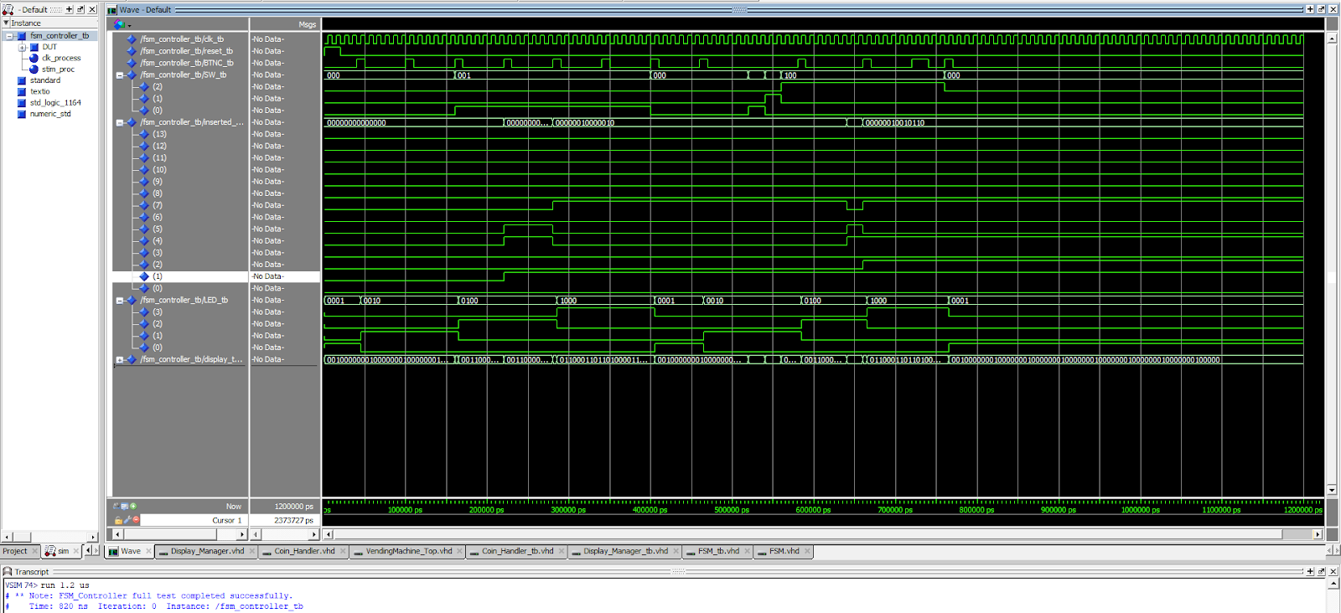
Figure 3. Results of FSM_Controller test bench [1]
Display_Manager_tb
The test bench for Display_Manager aimed to verify the correct 7-segment display patterns were generated for 6 different input strings. Those are:
- ‘01234567’ ‘89 AEObc’
- ‘ghlor ’ ‘colA0130’
- ‘bEEr0150’ ‘h2o 0090’
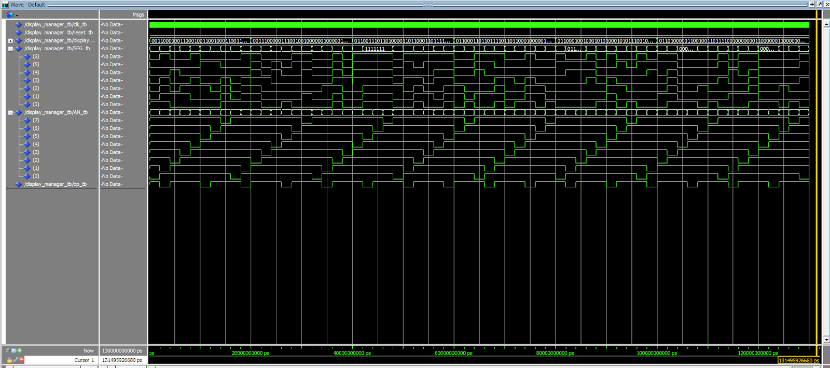
Figure 4. Results of Display_Manager test bench [1]
Coin_Handler_tb
The Coin_Handler test bench verified the component detects the rising edge of the buttons used for the coin insertion and increments the inserted amount. Those are:
- Insert 10 cents and see if the inserted amount is 10 cents
- Insert 20 cents and see if the inserted amount is 30 cents
- Insert 50 cents and see if the inserted amount is 80 cents
- Insert 100 cents = 1 euro and see if the inserted amount is 180 cents
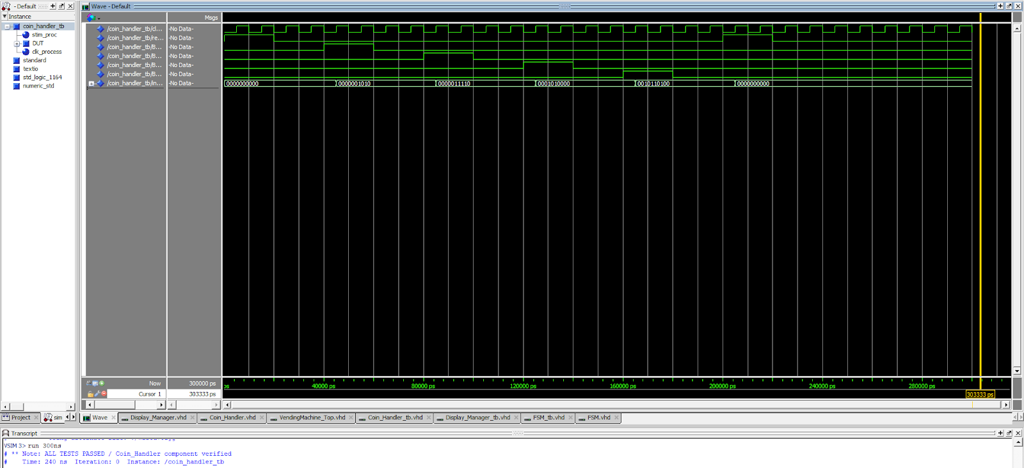
Figure 5. Results of Coin_Handler test bench [1]

6. FPGA Implementation and Results (Leano)
6.1 Overview of Project
This project implements one simple vending machine system based on FPGA. The user can select items, and insert different coins by using buttons. The system will detect the inserted value, and calculate the change, and interact with users by displaying output on 7-segment display. The FPGA used in our project is Diligent Nexys A7 and the supported software is Vivado. The block diagram of this project can be seen in the figure followed.
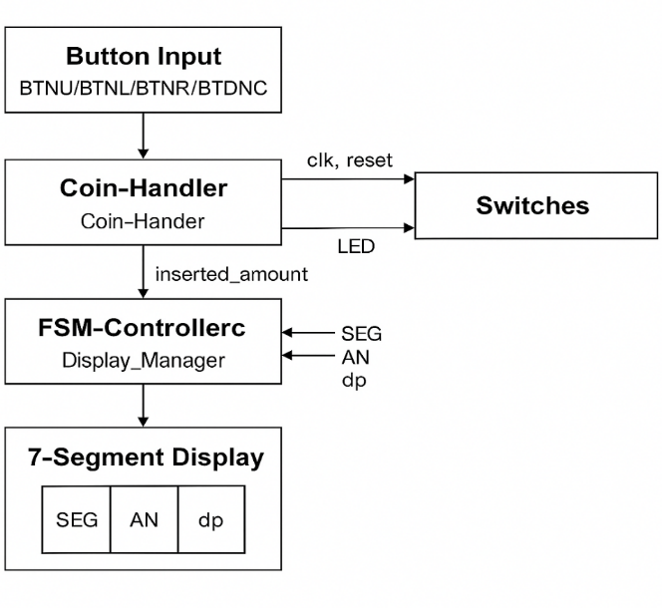
Figure 6. Block Diagram [1]
6.2 System Architecture
In the VHDL code, we have four modules: Coin_Handler, FSM_Controller, Display_Manager, and Top Module.
Coin_Handler
In this module, the system detects button presses and increases the inserted amount accordingly. Supports 4 coin values via BTNU, BTND, BTNL, BTNR (10, 100, 20, 50 cents respectively).
FSM_Controller
Main finite state machine controlling all vending machine logic: item selection, price validation, state transitions (IDLE, DISPLAY, INSERT, DISPENSE), LED status, and display string generation. Button BTNC is used to transition states, and switch M13, L16, and J15 are used to select different items in Display state.
Display_Manager
This module converts an 8-character ASCII string to 7-segment codes. Uses time-multiplexing to scan 8 digits and supports dynamic display updates.
Top Module : VendingMachine_Top
Instantiates and connects all modules: Coin_Handler, FSM_Controller, and Display_Manager.
In the xdc file below, the connection between VHDL module ports and FPGA board is provided, here you can observe the mapping between switches.
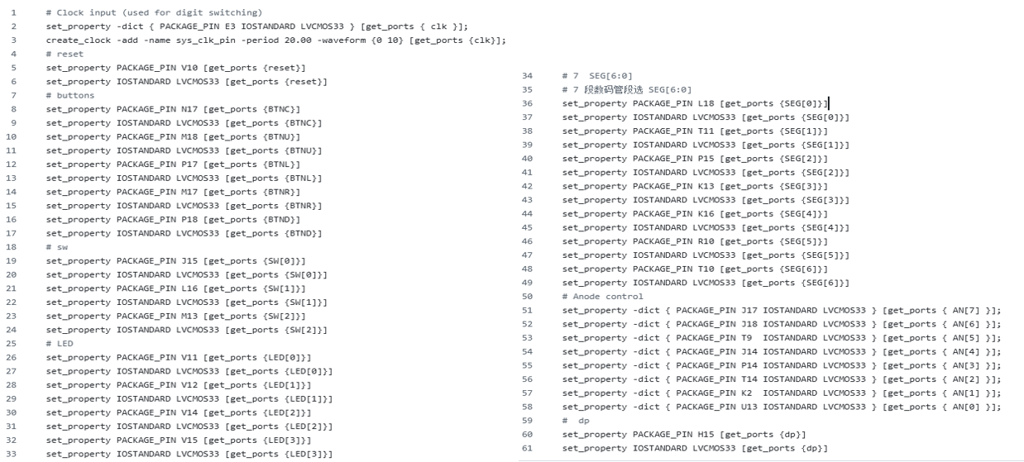
Figure 7. Constraint File [1]

6.3 FPGA Synthesis & Implementation Results
Synthesis
The design was synthesized using Xilinx Vivado 2024.2 for the xc7a100tcsg324-1 FPGA device. Below is the resource utilization summary:
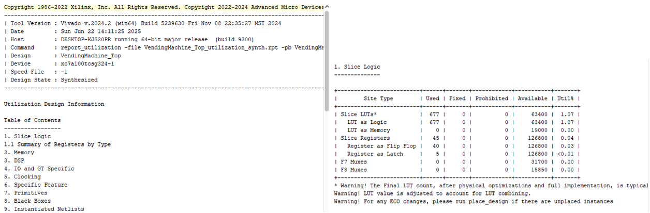
Figure 8. Synthesis Report [1]
Hardware Implementation
After synthesis:
- Bitstream generated and loaded successfully onto the FPGA board.
- Timing met for target frequency.
- The device is programmed.
7. PCB Prototyping and Results (Emaan)
To implement the PCB design, I started by creating the circuit schematic, selecting and connecting all necessary components. Then, I assigned footprints, arranged the layout, and routed the connections using KiCad. Finally, I reviewed the 3D view and design rules to ensure everything was ready for fabrication.
The complete PCB design provides a custom hardware platform for vending machine FPGA. It includes all essential components and allows for future expansion using extra I/O pins. Below are the final stages of our PCB design:

7.1 Schematic Design
The schematic is the first step in PCB development. It shows the logical circuit, including all components and their connections, ensuring correct circuit behavior before layout. Our schematic includes, as can be seen in Figure 9:
- The main FPGA chip
- Power supply circuit
- 7-segment display connections
- Resistors and Capacitors
- RGB LED circuits
- Transistors
- Switch connections
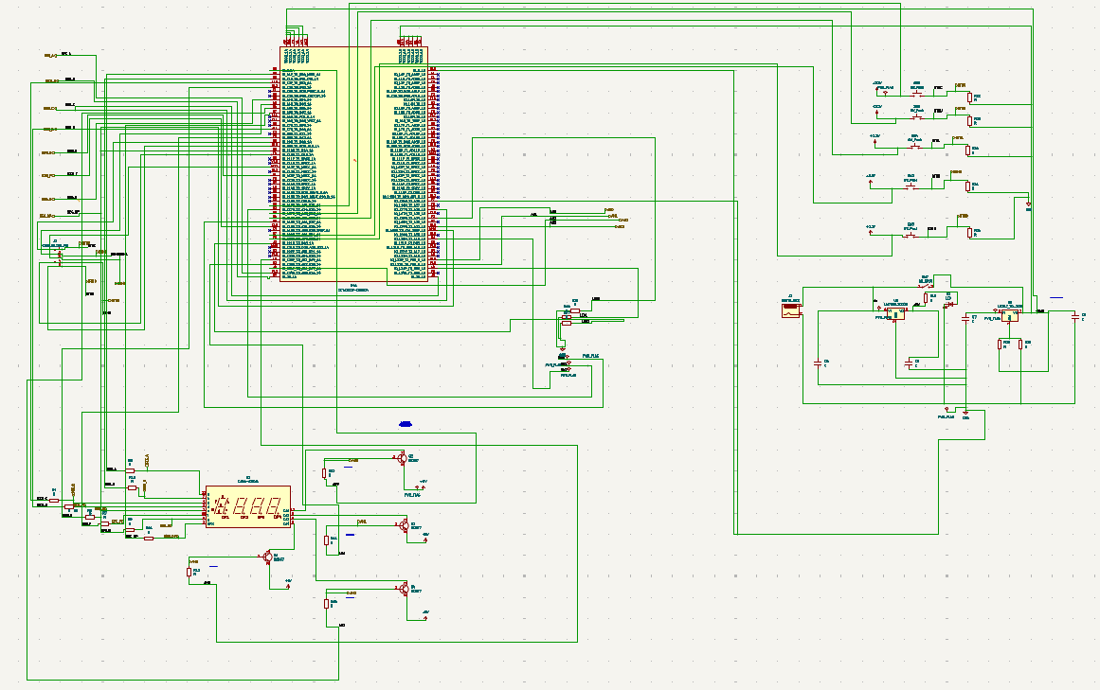
Figure 9. Schematics [1]
7.2 3D View
KiCad’s 3D viewer gives a realistic preview of the final PCB, helping verify component spacing, overall appearance, and detect issues before fabrication. The 3D view shows:
- The physical placement of all components on the board
- The board’s overall dimensions and shape
- The location of mounting holes and connectors
- The visual appearance of the PCB, including silkscreen labels and component outlines.
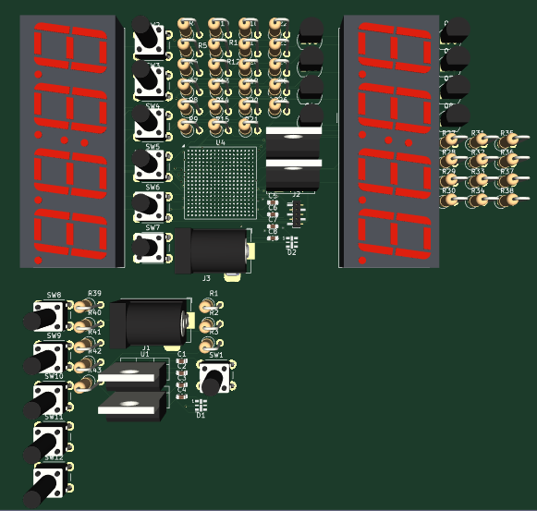
Figure 10. 3D View [1]
7.3 Routing
After completing the schematic, the next step was to translate the logical connections into physical traces on the PCB. The routing process is crucial for ensuring that the final PCB will function correctly and be manufacturable. The routing process involved:
• Placing components in optimal positions for signal integrity and ease of use
• Routing traces between components, ensuring proper clearances and adhering to design rules
• Creating separate power and ground planes for better signal integrity
• Minimizing trace lengths for critical signals

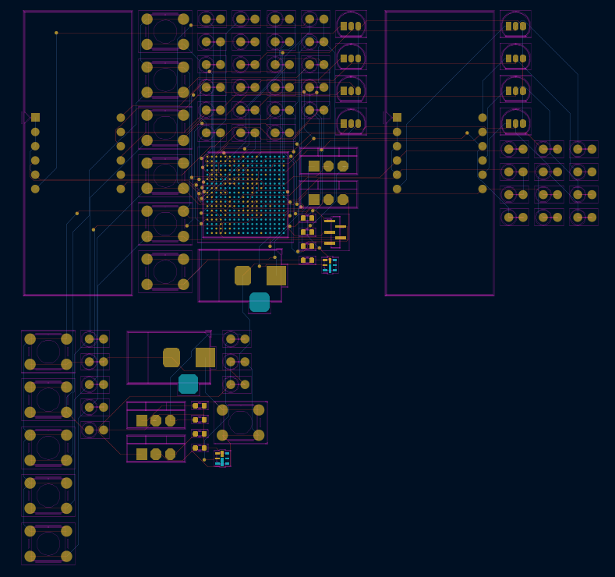
Figure 11. PCB Layout [1]

7.4 BOM and Cost for manufacturing Using Gerber Files
According to the BOM list for this PCB we did use total 12 different elements. For Generating Building Of Material (BOM) I used a built in KiCad plugin, generate Interactive HTML BOM, to find out the cost for manufacturing I upload the Gerber file on JLCPCB.
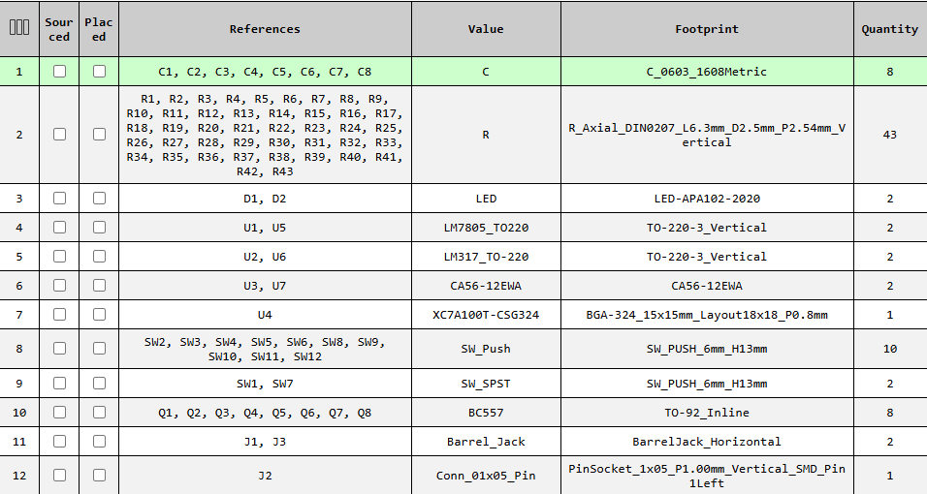
Figure 12. Bill of Materials [1]
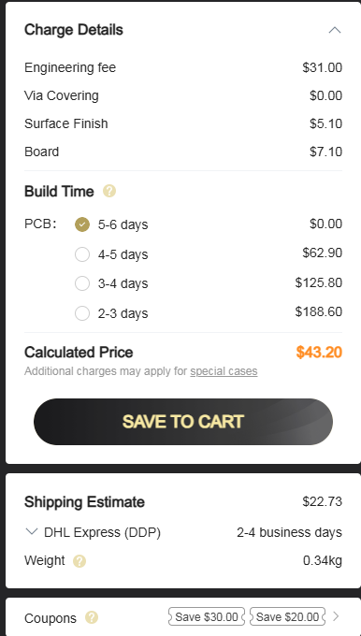
Figure 13. Cost [1]
7.5 Gerber files
Gerber files are special files used to describe each layer of a PCB design. They contain instructions for drawing things like copper traces, holes (vias), pads, solder masks, and labels. These files are created by PCB design software and are used by manufacturers to build the actual circuit board. These files often have extensions like .gb or .gbr. [8]
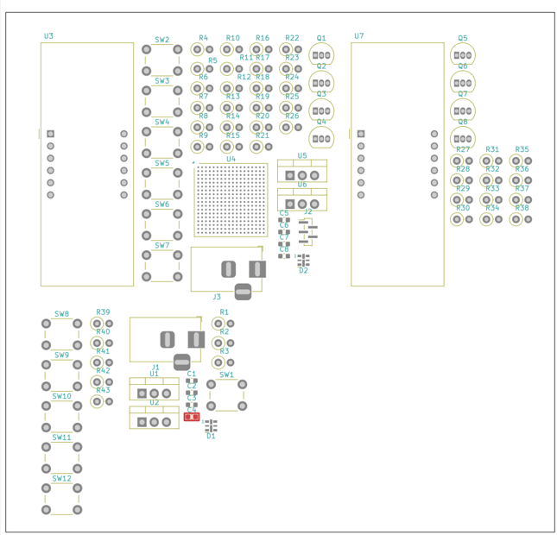
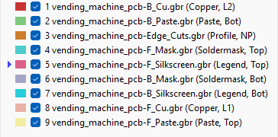
Figure 14. Gerber Files Layers [1]
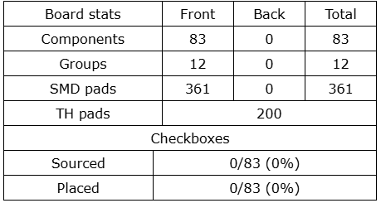
Figure 16. PCB Image [1]
Figure 15. Board Stats [1]

8. Sources and References (Everyone)
[1] https://github.com/yoonsukwkd96/SS2025_HWE_Lab_Team1_VendingMachine
[2] https://agilealliance.org/agile101/
[3] IEEE Standard VHDL Language Reference Manual, IEEE 1076-2019.
[4] Siemens EDA - ModelSim Product Overview https://eda.sw.siemens.com/en-US/ic/model/
[5] Roth, C. H., & John, L. L. (2016). Digital Systems Design Using VHDL, 3rd Edition.
[6] Cadence PCB Solutions (2023) PCB design layout guidelines and Best Practices for Engineers, Cadence.
[7] Peterson , Z. (2020) What is a printed circuit board? make circuits by connecting components, Altium.
[8] Team, V.E. (2024) Gerber Files explained, VSE.
[9] Final proof reading and compilation of the report and repository organization were done by Younsuk Choi

9. Appendix (Everyone)
Every single material on this report can be found on our project Git Repository. [1]
9.1 VHDL Codes

9.1.1 VendingMachine_Top.vhd
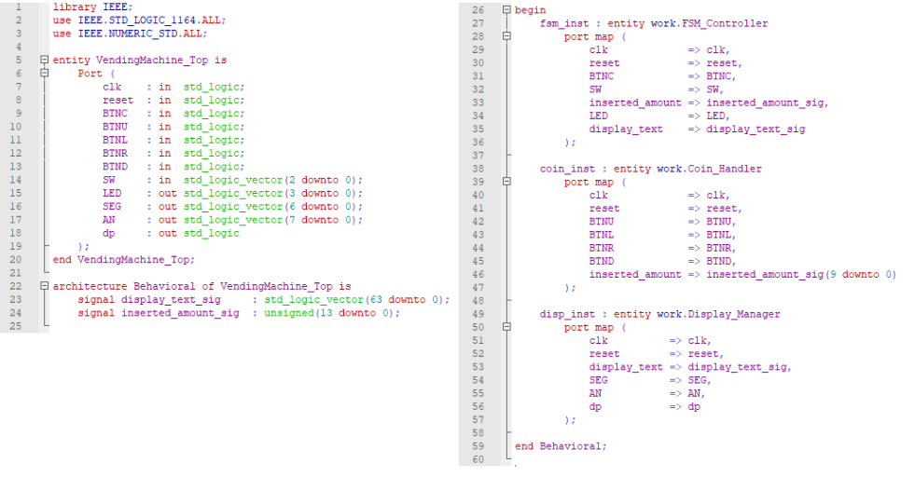

9.1.2 FSM_Controller.vhd

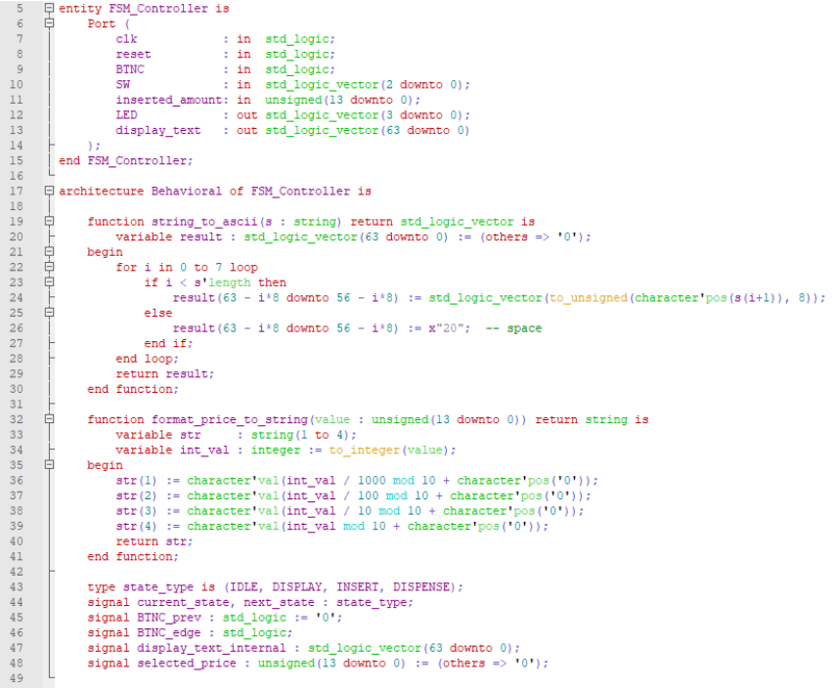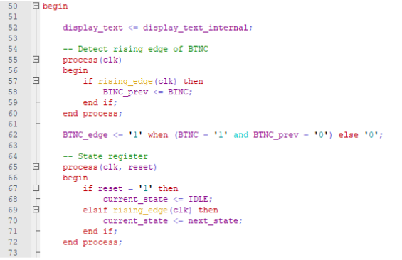
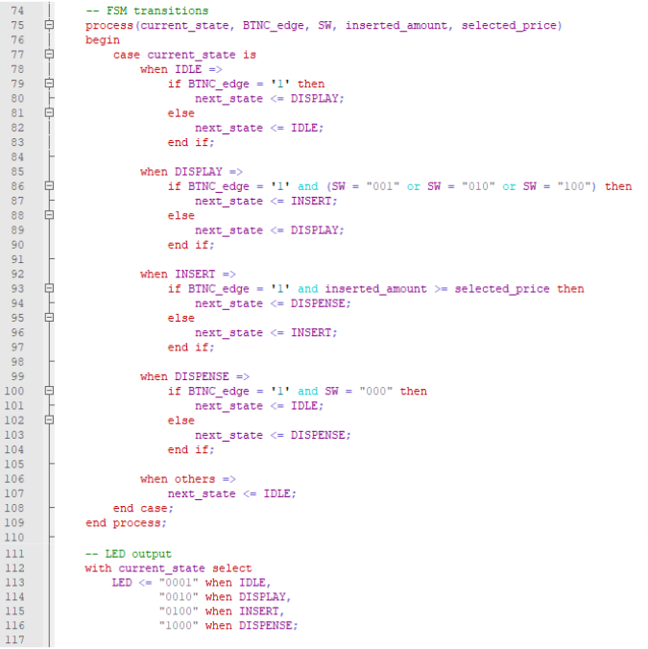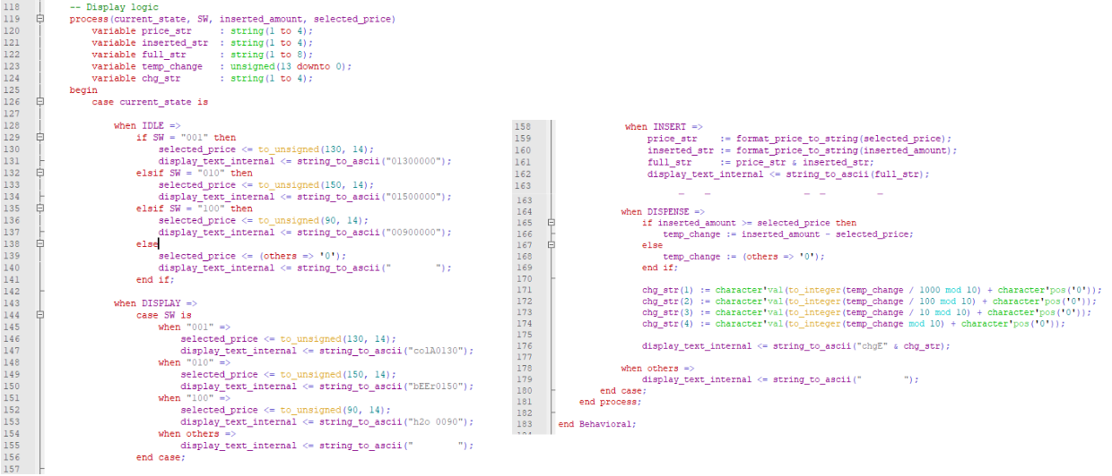

9.1.3 Display_Manager.vhd

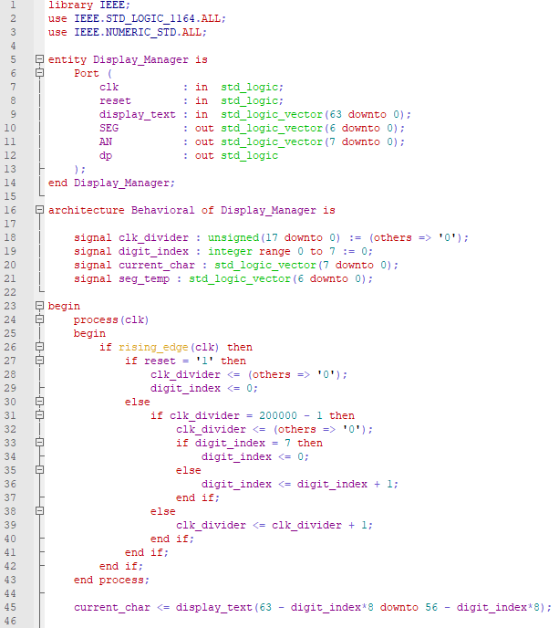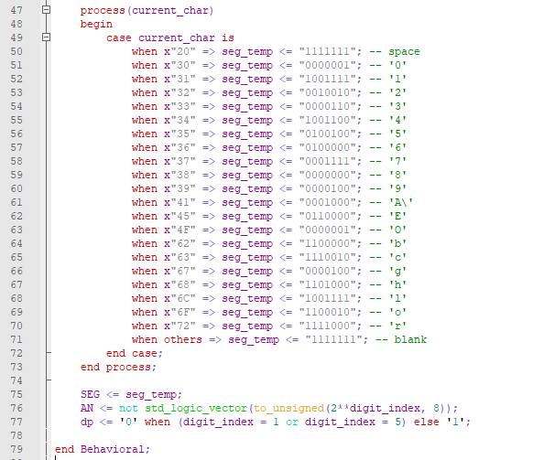

9.1.4 Coin_Handler.vhd
